
FT/CSQP/1121/B 21-SEP-2021
FIRST TERM EXAMINATION (2021-22)
Subject: COMPUTER SCIENCE  Grade: XI |  |  | Max. Marks:35  Time:1 Hr. 30 Mins
Name: |  |  |  |  | Section: | Roll No:
General Instructions:
General Instructions:
The question paper is divided into 3 Sections - A, B and C.
• Section A, consist of 25 Questions (1-25). Attempt any 20 questions.
• Section B, consist of 24 Questions (26-49). Attempt any 20 questions.
• Section C, consist of 6 case study-based Questions (50-55). Attempt any 5 questions.
• All questions carry equal marks.
- The question paper has 9 printed pages.
SECTION A
Attempt 20 questions from this section. Choose the most suitable option.
 | Which of the following symbol is used in Python for single line comment?
 | a. | // |  | b. | /*
 | c. | # |  | d. | ‘’
2. | Which of the following is non volatile memory?
 | a. | RAM |  | b. | ROM
 | c. | Hard disk |  | d. | All of the above
3. | 0 and 1 in binary numbering system are called binary digits or
 | a. | bits |  | b. | bytes
 | c. | KB |  | d. | Decimal bytes
4. | What do we use to define a block of code in Python language?
 | a. | Key |  | b. | Brackets
 | c. | Indentation |  | d. | Comments
5. | Find the invalid identifier from the following:
 | a. | pricein$ |  | b. | _price
 | c. | true |  | d. | Addr1
6. | Which of the following precedence order is correct in Python?
 | a. | Exponential, Parentheses, Multiplication/Division, Addition/Subtraction
 | b. | Multiplication/Division, Addition/Subtraction, Parentheses, Exponential
 | c. | Parentheses, Exponential, Multiplication/Division, Addition/Subtraction
 | d. | Division/Multiplication, Addition/Subtraction, Parentheses, Exponential
7. | Which of the following declarations is incorrect in python language?
 | a. | xyzp = 5,000,000 |  | b. | x y z p = 5000 6000 7000 8000
 | c. | x,y,z,p = 5000, 6000, 7000, 8000 |  | d. | x_y_z_p = 5,000,000
8. | Which among the following is responsible for the management and coordination of activities and sharing of the resources of the computer?
 | a. | Operating System |  | b. | Application Software
 | c. | Utility Software |  | d. | Business software
9. | Operators with the same precedence are evaluated in which manner?
 | a. | Right to Left |  | b. | Can not say
 | c. | Left to Right |  | d. | None of the above
10. | What is the return type of function id ?
 | a. | int |  | b. | float
 | c. | string |  | d. | dict
11. | What error occurs when you execute?  apple = mango
 | a. | SyntaxError |  | b. | NameError
 | c. | ValueError |  | d. | TypeError
12. | The expression of a NAND gate is_______
 | a. | A.B |  | b. | A’B+AB’
 | c. | (A.B)’ |  | d. | (A+B)’
13. | The base of hexadecimal number system is
 | a. | 8 |  | b. | 10
 | c. | 2 |  | d. | 16
14. | Which of the following option is not a core data type in the python language?
 | a. | dictionary |  | b. | Lists
 | c. | Class |  | d. | All of the above
15. | Select the correct example of complex datatype in Python
 | a. | 3 + 2j |  | b. | -100j
 | c. | 5j |  | d. | All of the above are correct
16. | If x=3.123, then int(x) will give ?
 | a. | 1 |  | b. | 0
 | c. | 123 |  | d. | 3
17. | Which statement is true from following-
 | a. | List is mutable & Tuple is immutable |  | b. | List is immutable & Tuple is mutable
 | c. | Both are Mutable |  | d. | Both are Immutable
18. | Special meaning words of Pythons, fixed for specific functionality are called ………
 | a. | Identifiers |  | b. | functions
 | c. | Keywords |  | d. | literal
19. | DE Morgan’s law states that
 | a. | A’ + B’ = A’B’ |  | b. | (AB)’ = A’ + B
 | c. | (AB)’ = A’ + B’ |  | d. | (A + B)’ = A’ * B
20. | Which out of the following binary number is equivalent to decimal number 24
 | a. | 11011 |  | b. | 11000
 | c. | 11111 |  | d. | 11001
21. | Which of following is not a decision-making statement?
 | a. | if-elif statement |  | b. | for statement
 | c. | if -else statement |  | d. | if statement
22. | The ……….. operator tests if a given value is contained in a sequence or not.
 | a. | Is |  | b. | in
 | c. | Not in |  | d. | none
23. | A graphical representation of an algorithm to solve a problem is called ……………
 | a. | flow of data |  | b. | barchart
 | c. | flow chart |  | d. | none
24. | Which of the following is False regarding loops in Python?
 | a. | Loops are used to perform certain tasks repeatedly
 | b. | While loop is used when multiple statements are to executed repeatedly until the given condition becomes true.
 | c. | While loop is used when multiple statements are to executed repeatedly until the given condition becomes false
 | d. | For loop can be used to iterate through the elements of lists
25. | Data items having fixed value are called ……….
 | a. | Identifiers |  | b. | functions
 | c. | Keywords |  | d. | literals
SECTION B
Attempt 20 questions from this section.
 | Q26-Q35 Predict the output of the given code segment:
26. | n=11  for i in range(2, n//2):  if n%i==0:  print(n)  break  else:  print("Bye")
 | a. | 11 |  | b. | 2
 | c. | Bye |  | d. | 11 Bye
27. | a = True  b = False  c = False  if not a or b:  print (1)  elif not a or not b and c:  print (2)  elif not a or b or not b and a:  print (3)  else:  print (4)
 | a. | 1 |  | b. | 2
 | c. | 3 |  | d. | 4
28. | i = 0  while i < 3:  print i  i += 1  else:  print 0
 | a. | 0 1 2 0 |  | b. | 0 1 2
 | c. | 0 |  | d. | 1 2 0
29. | a = 110  while a > 100:  print(a, end=’#’)  a –= 2
 | a. | 110#108#106#104#102#100# |  | b. | 110#108#106#104#102#
 | c. | 110#108#106#104#102# |  | d. | None of the above
30. | X wants to allow the program to repeatedly ask the user to enter their Choice if it does not equal the Answer. Which loop option should X use?
 | a. | while Choice = = Answer:  Choice = input() |  | b. | while Choice != Answer:  Choice = input()
 | c. | while Answer != Choice:  Choice = input() |  | d. | while Answer = = Choice:  Choice = input()
31. | x = 'abcd '  for i in range(len(x)):  print(x)  x = 'a'
 | a. | a |  | b. | abcd abcd abcd abcd
 | c. | a a a a |  | d. | abcd abcd abcd
32. | a = int(input("Enter an integer: "))  b = int(input("Enter an integer: "))  if a <= 0:  b = b +1  else:  a = a + 1  if a > 0 and b > 0:  print ("W")  elif a > 0:  print("X")  if b > 0:  print("Y")  else:  print("Z")  What will be printed if the user enters -1 for a and -1 for b?
 | a. | W |  | b. | X
 | c. | WZ |  | d. | Z
33. | for x in range(4):  for y in range(3):  if x+1==y or y+x==2:  print("*",end=" ")  else:  print("0",end=" ")  print()
 | a. | 0 * *  0 * *  * 0 0  0 0 0 |  | b. | 0 * *  0 * 0  * 0 0  0 0 *
 | c. | 0 * *  0 * *  * 0 *  0 0 0 |  | d. | 0 * *  0 * 0  * 0 0  0 0 0
34. | What will be the output produced by the three expressions of the code given below?  a, b, c, d = 5, -3, 25, -10  print(a + b + c > a + c – b * d)  print(str(a + b + c > a + c – b * d) = = ‘true’)  print(len(str(a + b + c > a + c – b * d)) = = len(str(bool(1))))
 | a. | True  True  True |  | b. | True  False  True
 | c. | True  True  False |  | d. | False  True  False
35. | i=5  while i>=0:  j=1  while j<=i:  print(j,end=' ')  j+=1  print()  i-=1
 | a. | 1 2 3 4 5  1 2 3 4  1 2 3  1 2  1 |  | b. | 1  1 2  1 2 3  1 2 3 4  1 2 3 4 5
 | c. | 5 4 3 2 1  5 4 3 2  5 4 3  5 4  5 |  | d. | 5  5 4  5 4 3  5 4 3 2  5 4 3 2 1
36. | How many times will the following code be executed?  c=10  while c>0:  print(c)  c-1  print("End")
 | a. | 10 |  | b. | 11
 | c. | 0 |  | d. | Infinite
37. | The result after converting the binary number (100011)2 to decimal will be
 | a. | 30 |  | b. | 43
 | c. | 35 |  | d. | 32
38. | Convert hexadecimal (EB4A)16 to its equivalent octal.
 | a. | 165512 |  | b. | 156641
 | c. | 165511 |  | d. | 165012
39. | 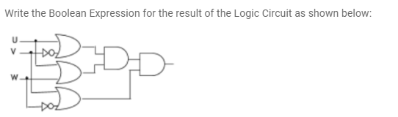
 | a. | (U+V’)+(U+W).(V+W’) |  | b. | (U+V’).(U+W).(V+W’)
 | c. | (UV’).(U+W).(V+W’) |  | d. | (UV’).(U+W).(VW’)
40. | What is the logical expression for the following:  Donation in the range of4000-5000 or guest=1
 | a. | donation>=4000 and donation<=5000) or guest==1
 | b. | donation>=4000 or donation<=5000 or guest==1
 | c. | donation>=4000 and (donation<=5000 or guest==1)
 | d. | donation>=4000 and donation<=5000) or guest==1
41. | Which among the following sequence will range(7, -6, -4) create?
 | a. | [7, 4, 1, -2, -5] |  | b. | [7, 3, -1]
 | c. | [7, 3, -1, -3, -5] |  | d. | [7, 3, -1, -5]
42. | What will be the output of the following Boolean expression using truth table  XY’(Z +YZ’) + Z’
 | a. | 1 0 1 0 1 0 1 1 |  | b. | 1 0 1 0 1 1 0 1
 | c. | 1 0 1 0 1 1 1 0 |  | d. | 1 0 1 0 1 1 0 0
43. | Predict the output of the given code segment for the input value 45.  n=int(input("Enter the number:"))  a=0  m=0  c=1  while n>0:  a=n%2  m+=(a*c)  c=c*10  n=int(n/2)  print(m)
 | a. | 100010 |  | b. | 100101
 | c. | 101101 |  | d. | 101001
44. | Write the Boolean expression for the result of the logic circuit given below:  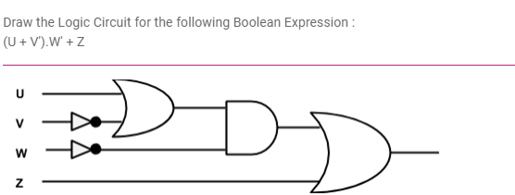
 | a. | (U + V’) + W’ + Z |  | b. | U + V’ + W’ + Z
 | c. | (U + V’) . W’ + Z |  | d. | None of the above
45. | Identify the correct program code for the given flowchart:  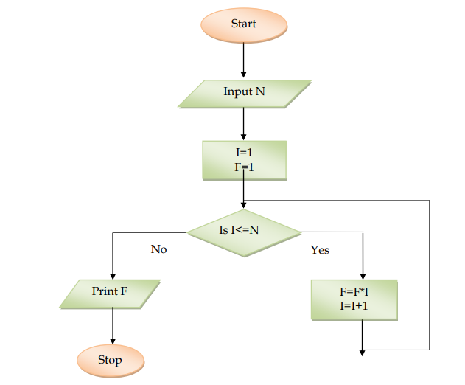
 | a. | n=int(input("Enter the no: "))  for i in range(1,n+1):  f*=i  print(f) |  | b. | n=int(input("Enter the no: "))  f=1  for i in range(1,n+1):  f+=i  print(f)
 | c. | n=int(input("Enter the no: "))  f=1  for i in range(1,n):  f*=i  print(f) |  | d. | n=int(input("Enter the no: "))  f=1  for i in range(1,n+1):  f*=i  print(f)
46. | There are errors in the code given below. Identify the corrected code from the options provided.  S = input(“Enter season: “)  If s=w:  Print(“Winter Season)  Else if s=r:  Print(“rainy season)  Else:  Print(‘Summer Season’)
 | a. | s = int(input("Enter season: "))  if s='w':  print("Winter Season")  elif s='r':  print("Rainy Season")  else:  print("Summer Season") |  | b. | s = input("Enter season: ")  if s==’w’:  print(“Winter Season")  elif s=='r':  print(“Rainy Season")  else:  print("Summer Season")
 | c. | s = input("Enter season: ")  if s=='w':  print("Winter Season")  elif s=='r':  print("Rainy Season")  else:  print("Summer Season") |  | d. | s = input("Enter season: ")  if s==’w’:  print(“Winter Season")  elif s=='r':  print(“Rainy Season")  else if :  print("Summer Season")
47. | Conversion of hexadecimal number (69)16 to octal equivalent will be
 | a. | 451 |  | b. | 351
 | c. | 251 |  | d. | 151
48. | Write the output of the following Python code:  for i in range(2,7,2):  print(i,i*'$', end='!', sep='#')
 | a. | 2 $$!4 $$$$!6 $$$$$$! |  | b. | 2$$!4$$$$!6$$$$$$!
 | c. | 2#$$!3#$$$$!4# $$$$5#$$$$$! |  | d. | 2#$$!4#$$$$!6#$$$$$$!
49. | Write the logical expression:  place is either ‘Delhi’ or ‘Goa’ but not ‘Jaipur’
 | a. | place= =’Delhi’ and place = =’Goa’ and place !=’Jaipur’
 | b. | (place= =’Delhi’ or place = =’Goa’) and place !=’Jaipur’)
 | c. | (place= =’Delhi’ or place = =’Goa’ and place !=’Jaipur’)
 | d. | (place= =’Delhi’ or Place = =’Goa’ or place !=’Jaipur’)
SECTION C
CASE STUDY based questions. This section consists of 6 questions. Attempt any 5.
Mukesh has made a python program using nested for printing a pattern. He used two functions chr( ) and ord( )to get the following output. He wrote the following code to get this pattern.
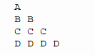
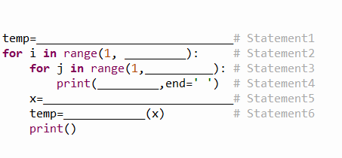

50. | Identify the statement 1
 | a. | A |  | b. | 65
 | c. | 1 |  | d. | 49
51. | Identify Statement 2
 | a. | 4 |  | b. | 5
 | c. | 6 |  | d. | 7
52. | Identify statement 3
 | a. | i+1 |  | b. | 5
 | c. | 6 |  | d. | j+1
53. | Identify statement 4
 | a. | i |  | b. | ord(temp)
 | c. | temp |  | d. | j
54. | Identify statement 5
 | a. | ord(temp+1) |  | b. | ord(1)+temp
 | c. | temp+1 |  | d. | ord(temp)+1
55. | Identify statement 6
 | a. | ord |  | b. | chr
 | c. | CHAR |  | d. | Ascii

***

